A

Report

On

World Philosophy Day 2018

Session :2018-19

Department of Philosophy

Rabindra Mahavidyalaya,

champadanga, Hooghly

Theme: World Philosophy Day

Venue: Rabindra Mahavidyalaya

Department of Philosophy

Room no 71

Date:27th November 2018

Organizer: Department of Philosophy

Objectives:

- To understand and respond to major contemporary challenges by creating the intellectual conditions for change
- To give a clear understanding of various subjects
- Realizing the Value of philosophy
- to make students understand the learning concepts and prepare them for the real world. Therefore, teachers have been incorporating different strategies to enhance the efficacy of the lecture methods
- For the development of thinking
- Stimulating intercultural dialogue
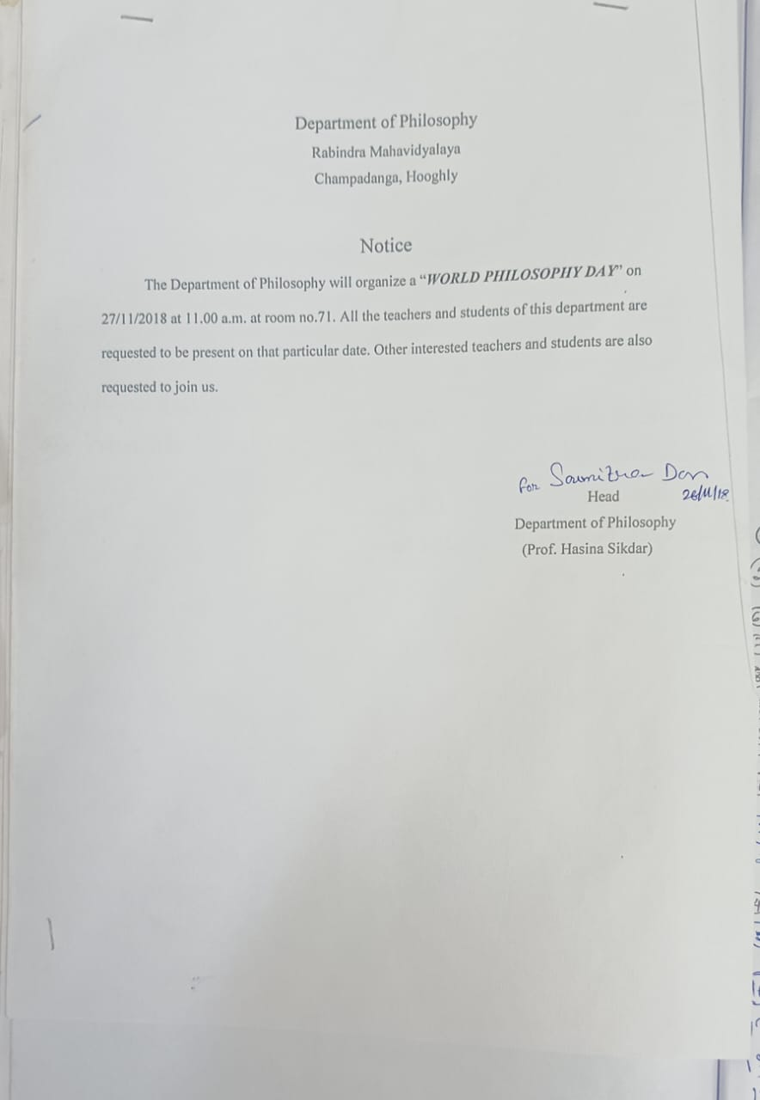

summary

On November 27th, 2018, World Philosophy Day was celebrated in the Department of Philosophy.Like every year the students of philosophy department have conducted the whole program. By celebrating World Philosophy Day each year, on the third Thursday of November, UNESCO underlines the enduring value of philosophy for the development of human thought, for each culture and for each individual. First, Professor Hasina Sikdar of Philosophy Department the lamp lighting in front of Radhakrishnan's portrait. In the portrait, flowers and garlands were given by prof. SuklaSaha.
Then the students performed an opening song. A short cultural program of half an hour with dance, song recital etc. After that begins the educational program.
A lecture session was held on that day. The topic was ‘Moral Values’. The speaker was prof. SoumitraDas, head of the Department of philosophy. Students like the lecture session very much. They learn a lot.

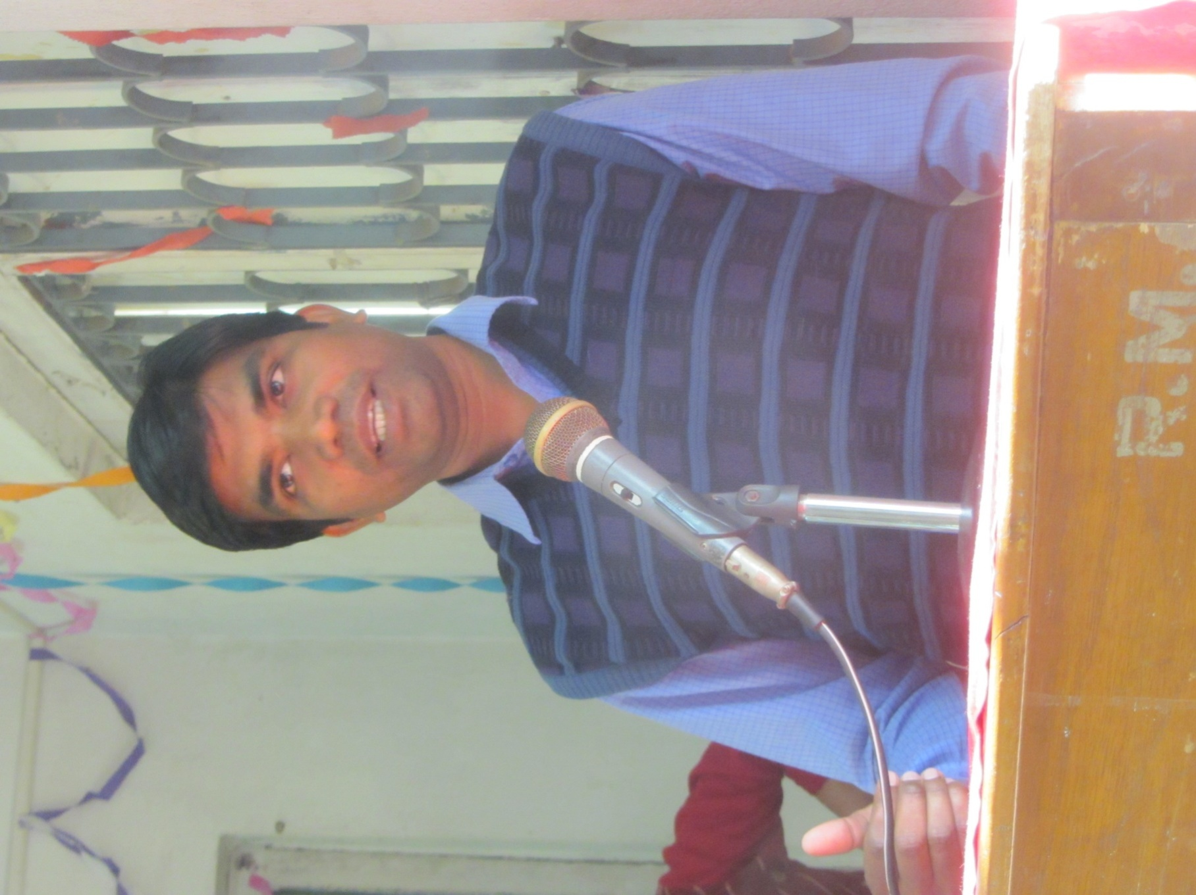
Speaker of this lecture session prof. SoumitraDas,Dept. oh Philosophy
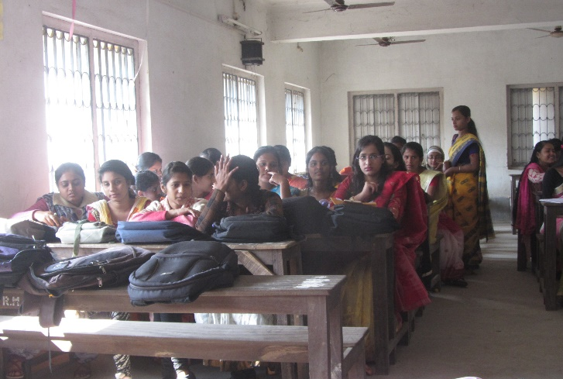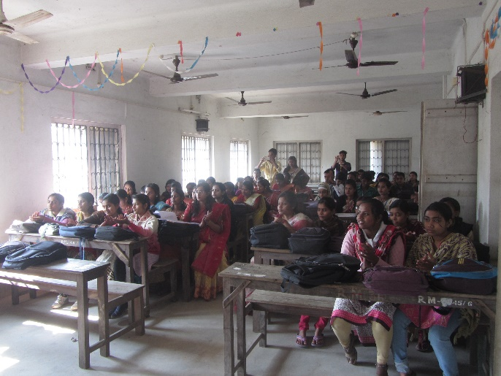

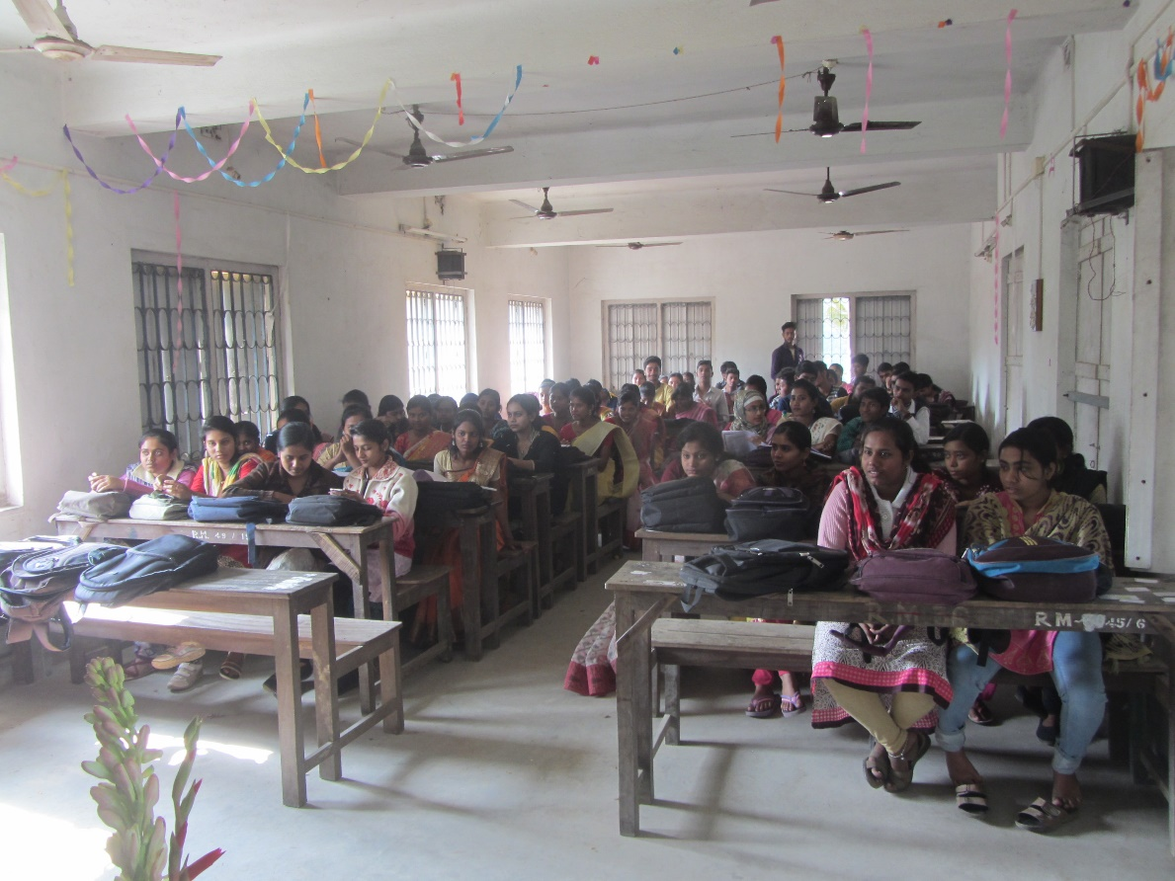
Audience

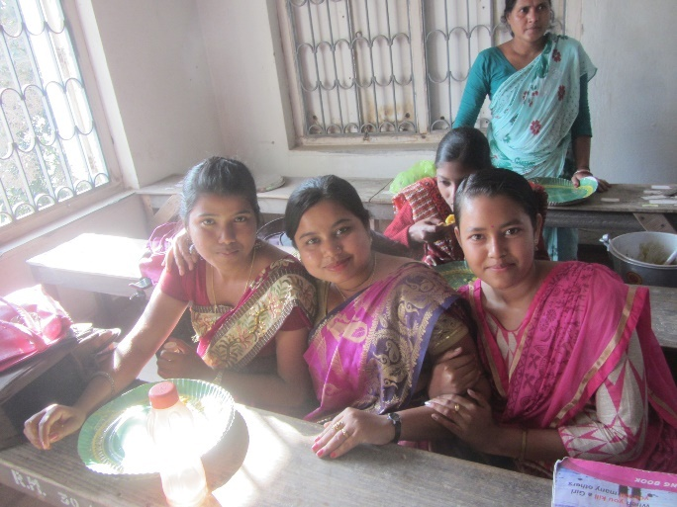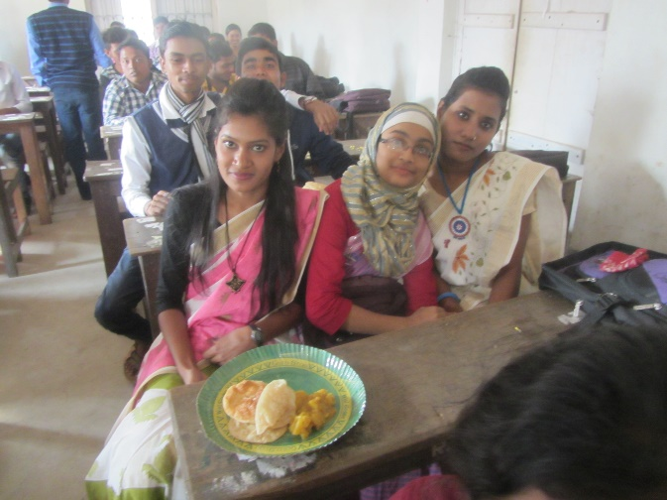

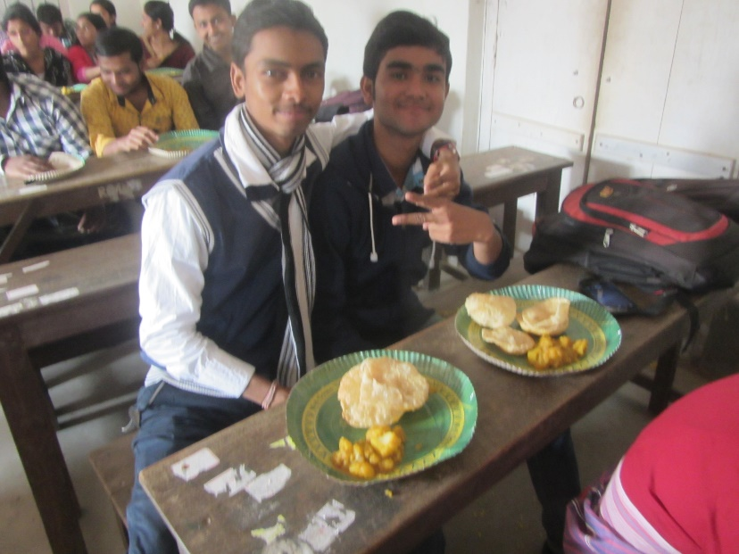
Lunch time

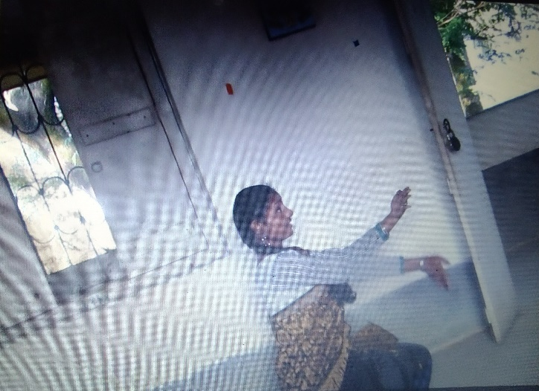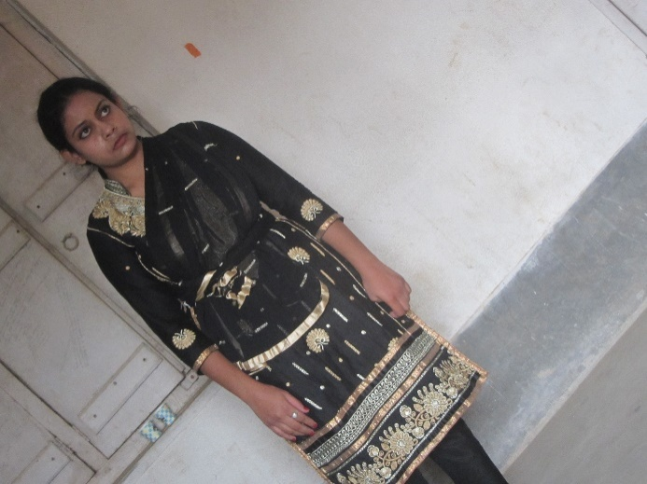
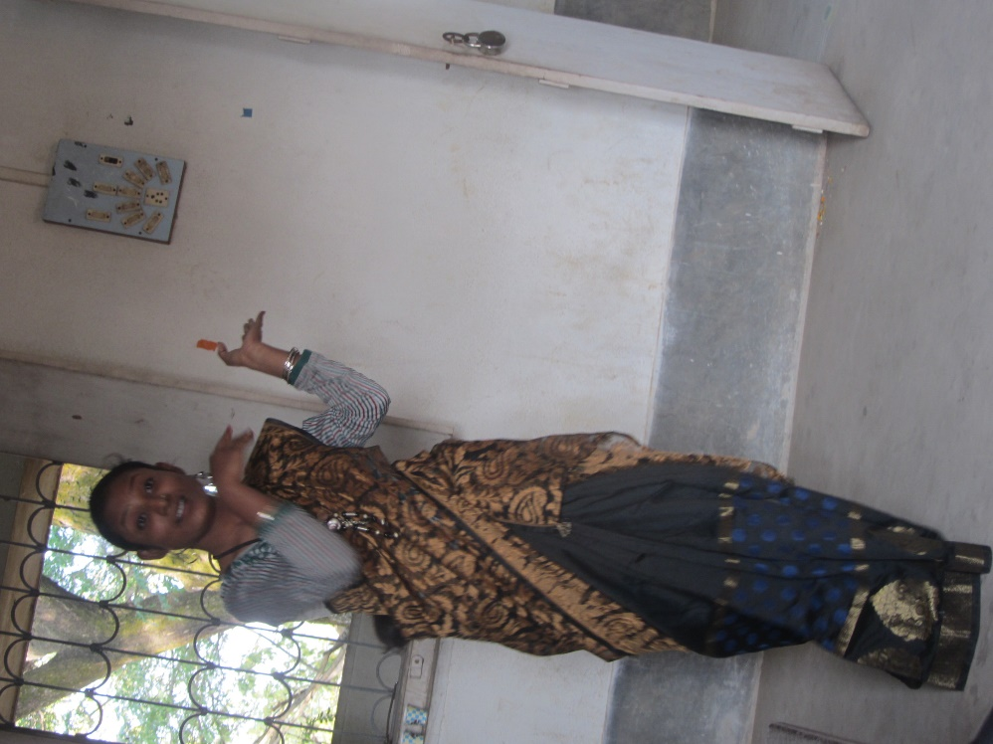
Performance by students

Attendance

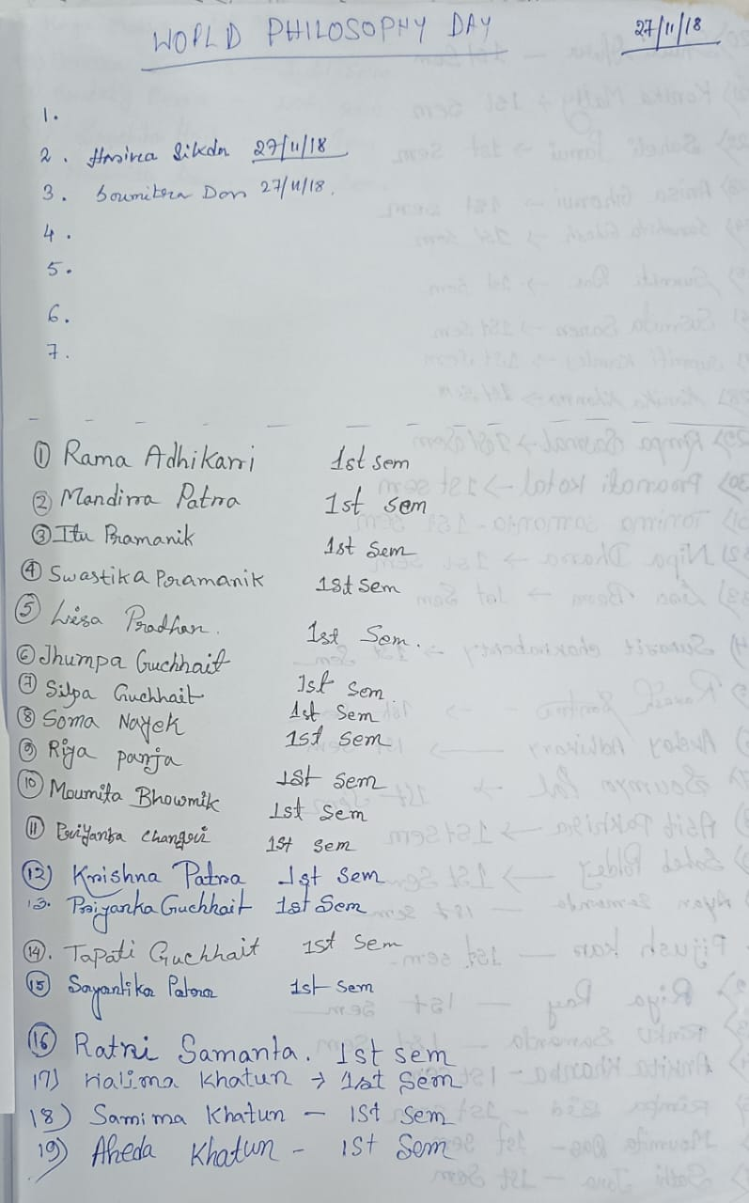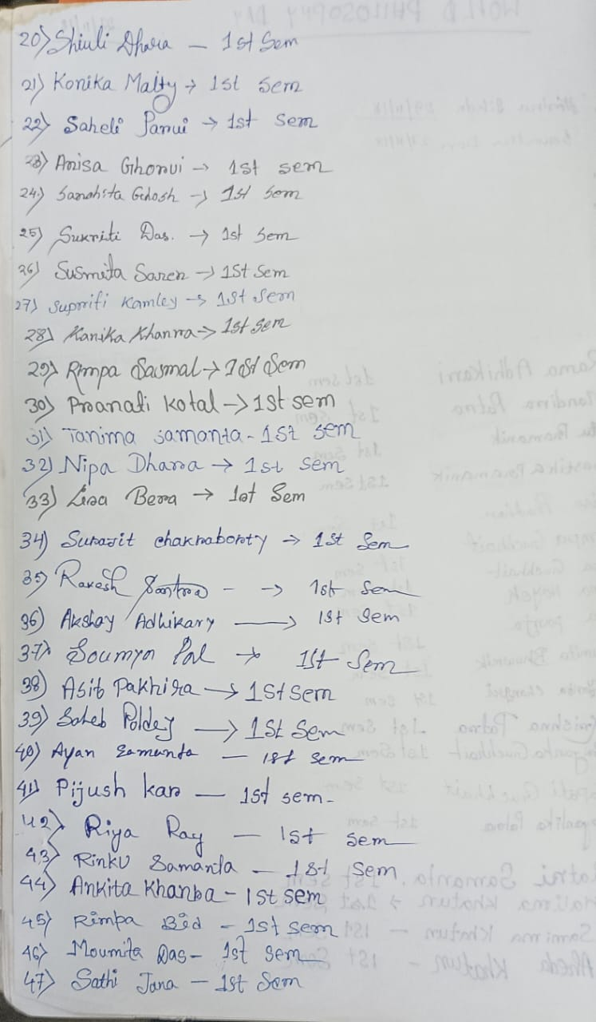

Our participants: more than 47
Male:17
Female:30

Tentative programme schedule
- Inaugural session: 11.30a.m. to 11.45a.m.
- Inaugural speech:11.45a.m. to 12 noon
- Other speech: 12noon to 12:30 p.m.
- Cultural programme: 12.30 p.m. to 1.00 p.m.
- Lunch break: 1.00 p.m. to 1:30 p.m.
- Lecture session: 1:30 p.m. to 3:30 p.m.

Feedback from students:

- 60% felt satisfactory
- 70 percent wished to occur the event more than once every year
- 100 percent students agreed this event helpe to improve their logical performance
- They want special class for grooming, more extra-curricular activities
- They want smart class room

